
VELAMMAL COLLEGE OF ENGINEERING AND TECHNOLOGY(AUTONOMOUS)
MADURAI-625009.

DEPARTMENT OF COMPUTER SCIENCE
21CE104 – MINI PROJECT

TICKET RESERVATION SYSTEM

A MINI PROJECT REPORT

TEAM MEMBERS PROJECT GUIDE
N.G.R.ABITHA-21CSE064 MR.G.BALAMURALI KRISHNAN
N.AFFRIN FOWMIYA-2CSE065 ASSISTANT PROFESSOR
C.NANDHINI-21CSE077 DEPARTMENT OF COMPUTER
S.SWETHA-21CSE091 SCIENCE AND ENGINEERING
VCET MADURAI

INDEX
CONTENTS | PAGE NO.

ABSTRACT
- OBJECTIVE
- SYSTEM REQUIREMENTS
- LIST OF C CONCEPTS
- FUTURE ENHANCEMENTS
- EXPLANATIONS OF MODULES
- FLOWCHART
- EXPLANATION
- CODE
- OUTPUT
- CONCLUSION
- BIBLIOGRAPHY
ABSTRACT

For journey of longer distances , though we have airways most of the people use the railways , which is most convenient , affordable means of transport in India

So keeping this in view , this program enables us to choose the train even there is no necessary to fill a form at the counter, i.e we can directly select from the choices provided for us with train numbers and their origin , departure time , destination and arrival time at that station and the class to travel in.

OBJECTIVE
Facilitates the passengers to enquiry about trains available on the basis of source and destination
Also it enables passengers to cancel their tickets
This project also enables passenger to enquire about the status of the booked ticket.

SYSTEM SPECIFICATION
HARDWARE SPECIFICATIONS
- Processor : Intel dual core
- Processor speed : 1.04GHZ
- Ram : 1GB
- Hard disc : 20GB hard disc
- Monitor : LCD
- Keyboard : MM Keyboard(Usb)
- Mouse : Optical mouse(Usb)

SOFWARE SPECIFICATIONS

- OS : Window 11
- Language : C language
- Turbo C7 version : Version 3.2

LIST OF C CONCEPTS:
CONCEPT | USED IN PROGRAM AS
Structure - | Struct S
Functions - | Booking,Availability,Cancellation and main function
Array - | Name[] , Address[]
Control Structure - | Switch  If()  …….  Else

FUTURE ENHANCEMENTS
- In future we would like to ask the passengers their choice of berth i.e.,(upper berth, middle berth and lower berth and) and price tickets accordingly.
- We would also like to mandatorily assign lower berth tickets for passengers below the age of 5 and above the age of 60.

EXPLANATION OF MODULES

Creation of “RAILWAY RESERVATION SYSTEM” based on 3 modules:

BOOKING:
In booking we have obtained the details of the passenger using the data’s inputted in the structure.
Here we have also included the number of ticket needed by the passenger.

CHECKING AVAILABILITY:
Here we check the availability of tickets in the class of the passenger’s choice i.e first class, second class, third class.
Now we have used switch (c) to select
1.First class
2.Second class
3.Third class

CANCELLATION:

If the passenger’s mind changed and he wants to cancel the ticket urgently then the software also has the facility of canceling the ticket on the spot. To cancel the ticket, the passenger should choose option 1.

FLOWCHART:
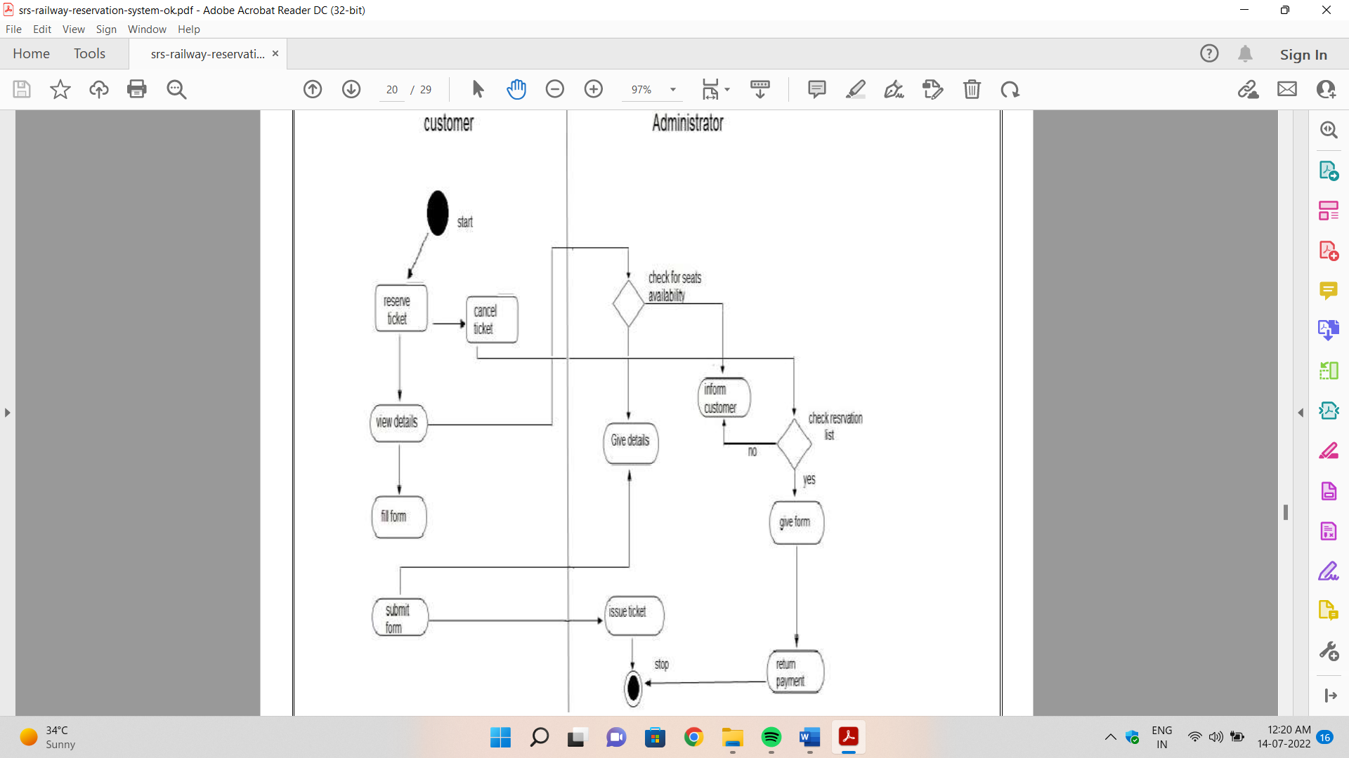
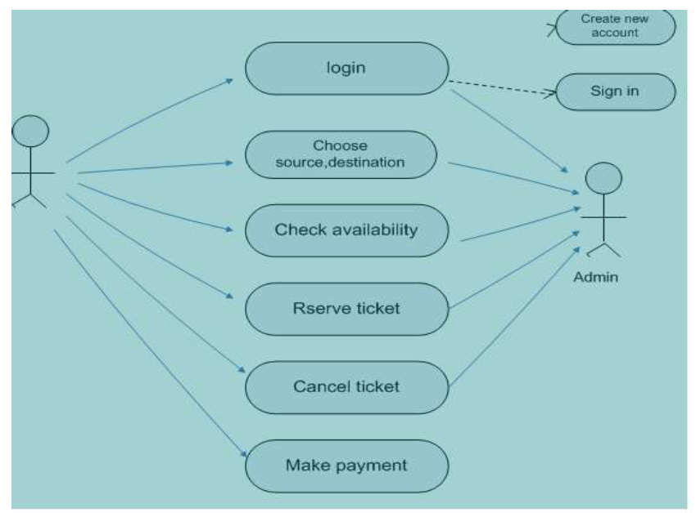
FLOWCHART;

EXPLANATION:
First we have included header files like <stdio.h>, <conio.h> and <stdlib.h> to input functions like printf(),scanf(), getch() ,clrscr().
We have initialized the number of first class tickets as 10, second class as 20, third class as 30.
We have defined a structure to input details of the passenger
The details include ticket number, phone number, name, age, aadhaar number.
We have created our program based on three modules:
*Booking
*Checking availability of seats
*Cancellation
VOID MAIN()
At first the flow of the program goes to the void main function defined by the user.
In this function we have called the
*booking()
*availability()
*cancel()
Then the flow of execution goes to the void booking () function definition of the program.
VOID BOOKING()
In void booking() we have obtained the details of the passenger using the data’s inputted in the structure.
Here we have also included the number of ticket needed by the passenger.
Next the flow of execution moves to void availability () function definition.
VOID AVAILABILITY()
Here we check the availability of tickets in the class of the passenger’s choice i.e., first class, second class, third class.
Now we have used switch (c) to select
1.First class
2.Second class
3.Third class
If we enter “1” the switch case goes to case 1
If first class tickets are greater than the number of tickets needed by the passenger, then the seats are available in the first class
Now the rate of first class tickets will be calculated per ticket and will be saved in the variable “total”
Variable a=1 is assigned
This variable will be explained in the upcoming function.
If we enter “2” the switch case goes to case 2
We check for second class seats, if second class tickets are greater than number of tickets, then seats are available in second class.
Now the amount to be paid for the second class tickets is calculated, and again here a=1 is assigned.
If we enter “3” the switch case goes to case 3
We check for third class seats, if third class tickets are greater than number of tickets, then seats are available in third class.
Now the amount to be paid for third class tickets is calculated, and again here a=1 is assigned.
If any other number is inputted, print “invalid choice”.
Next the flow of execution goes to void cancel().
VOID CANCEL ()
Now the code checks whether the passenger has booked a ticket or not.
If the condition is true we have a assigned a variable “c”.
If we want to cancel the ticket press “1” or else press any other number
This entered number gets stored in the variable “c”.
Now the cancellation works by checking if (c==1)
If this evaluates to true, print your ticket has been cancelled successfully or else exit.
Next the flow of execution goes to body part of void main function i.e., to the line next to the calling function.
Hence it prints “Thank you” and ends the program…

CODE:
#include<stdio.h>
#include<conio.h>
#Iinclude<stdlib.h>
int first=10,second=20,third=30,a;
struct node //defining a structure
{
int ticketno;
int phoneno;
char name[100];
int age;
int aadhar;
}s;
void booking() //defining a function for ticket booking
{
printf("\nStep 1: Ticket Booking\n");
printf("\n\tEnter details:\n");
printf("\t1.Name of the Passanger:");
scanf("%s",s.name);
printf("\t2.Contact Number:");
scanf("%d",&s.phoneno);
printf("\t3.Age:");
scanf("%d",&s.age);
printf("\t4.Aadhar Number:");
scanf("%d",&s.aadhar);
printf("\t5.Number of tickets needed:");
scanf("%d",&s.ticketno);
}
void availability() //defining a function for checking availability
{
int c,one=350,two=250,three=150,total;
clrscr();
printf("\nStep 2: Checking Availability of Ticket\n");
printf("\n\t1.First class\n\t2.Second class\n\t3.Third class\n");
printf("\n\tEnter your choice:");
scanf("%d",&c);
switch(c)
{
case 1:if(first>s.ticketno)
{
printf("\t\tSeats are available in First Class\n");
printf("\t\tTicket has been successfully booked in First Class\n");
one=one*s.ticketno;
total=one;
printf("\t\tAmount to be paid%d",total);
a=1;
first=first-s.ticketno;
}
else
{
printf("\t\tSeats are not available in First Class\n");
}
break;
case 2: if(second>s.ticketno)
{
printf("\t\tSeats are available in Second Class\n");
printf("\t\tTicket has been successfully booked in Second Class\n");
two=two*s.ticketno;
total=two;
printf("\t\tAmount to be paid%d",total);
a=1;
second=second-s.ticketno;
}
else
{
printf("\t\tSeats are not available in Second Class\n");
}
break;
case 3:if(third>s.ticketno)
{
printf("\t\tSeats are available in Third Class\n");
printf("\t\tTicket has been successfully booked in Third Class\n");
three=three*s.ticketno;
total=three;
printf("\t\tAmount to be paid%d",total);
a=1;
third=third-s.ticketno
}
else
{
printf("\t\tSeats are not available in Third Class\n");
}
break;
default:
printf("\nInvalid Choice");
break;
}
}
void cancel() //defining a function for cancellation
{
int c;
if(a==1
{
printf("\nStep 3: Cancellation of Ticket");
printf("\n\t\tIf you want to cancel the ticket...press 1\n \t\tElse press any other number: ");
scanf("%d",&c);
if(c==1)
{
printf("\n\t\tYour ticket has been cancelled successfully");
}
else
{
exit();
}
}
}
void main() //main() function
{
int n;
clrscr();
printf("\t\t*** Welcome to Railway Reservation System ***\t\t\t\n\n");
printf("Steps:\n");
printf("\t1.Ticket booking\n\t2.Checking availability of ticket\n\t3.Cancellation of ticket\n");
booking(); //calling the function
availability(); //calling the function
cancel(); //calling the function
printf("\n\n\t\t\t\t*** Thank You ***\t\t");
getch();
}

OUTPUT:

TICKET BOOKING:
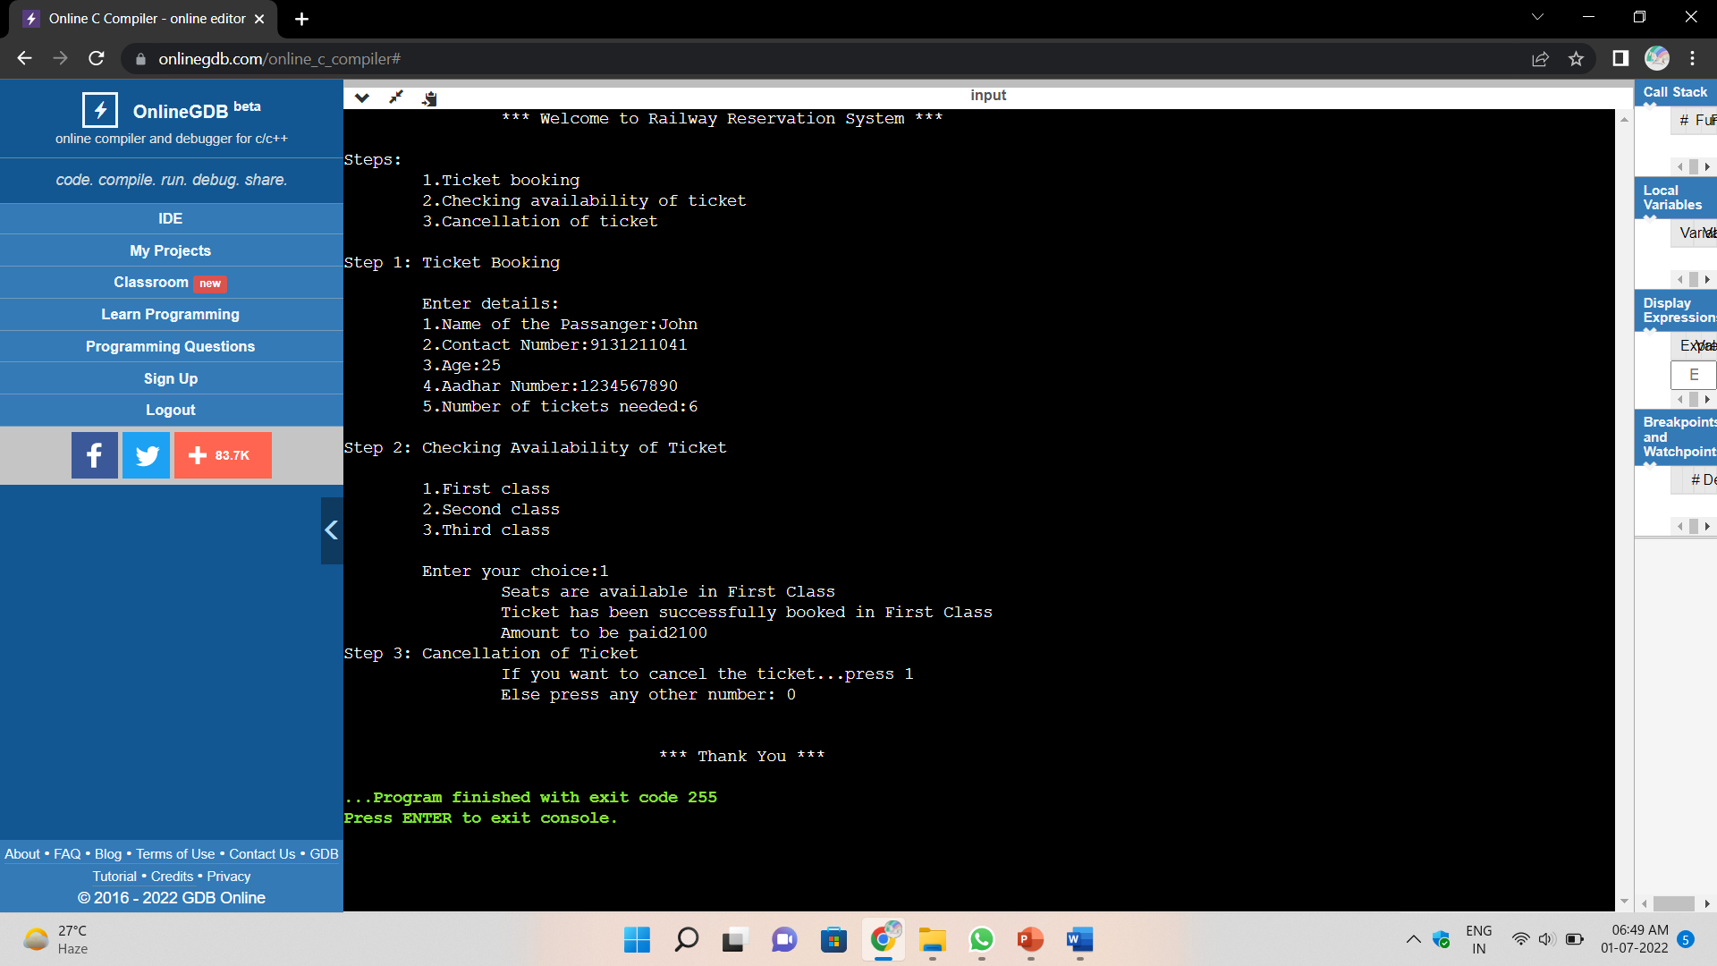

FIGURE: 1.1 BOOKING THE TICKET

CHECKING AVAILABILITY:
FIGURE: 1.2 CHECKING AVAILABILITY OF TICKET

CANCELLATION OF TICKET:
FIGURE: 1.3 CANCELLATION OF TICKETS

CONCLUSION
Practical Training is a very important part of the curriculum as it strengthens the concepts and enhances knowledge about the practical implementation of all the theory concepts, we have learnt so far in different subjects. This mini project helped us learn a lot. We did the project on railway reservation system. This project is used to keep a track on reserving the seat to the passenger. It helps managing the system very efficiently and conveniently. Finally, this gives us a lot of mental satisfaction that the project we have worked upon is a real time project, which will be installed at the customer site after some more session of regress testing.

BIBLIOGRAPHY

- Programming in c – Reema Thareja
- Programming in c – Kernigan & Ritchie
- https://www.geeksforgeeks.org/railway-reservation-system-in-c/
- https://sourcecodehero.com/railway-reservation-system-project-in-c-with-source-code/
- https://itsourcecode.com/free-projects/c-projects/railway-reservation-system-in-c-with-source-code-2/
- https://t4tutorials.com/railway-reservation-system-project-in-c/

- Backtracking
- Backtracking is a fairly common debugging approach that can be used successfully in
- small programs. Beginning at the site where a symptom has been uncovered, the
- source code is traced backward until the site of the cause is found.
- Brute Forcing
- This is the most common category of debugging which involves loading the source
- code with write statements and tracking line by line execution to isolate possible
- errors.
- Conclusion
- Practical Training is a very important part of the curriculum as it strengthens the
- concepts and enhances knowledge about the practical implementation of all the theory
- concepts, we have learnt so far in different subjects.
- This summer training helped us learn a lot. In this training we did the project on
- railway reservation system. This project is used to keep a track on reserving the seat to
- the passenger. It helps managing the system very efficiently and conveniently.
- Finally, this gives us a lot of mental satisfaction that the project we have worked upon
- is a real time project, which will be installed at the customer site after some more
- session of regress testing
onclusion
Practical Training is a very important part of the curriculum as it strengthens the
concepts and enhances knowledge about the practical implementation of all the theory
concepts, we have learnt so far in different subjects.
This summer training helped us learn a lot. In this training we did the project on
railway reservation system. This project is used to keep a track on reserving the seat to
the passenger. It helps managing the system very efficiently and conveniently.
Finally, this gives us a lot of mental satisfaction that the project we have worked upon
is a real time project, which will be installed at the customer site after some more
session of regress testing

Backtracking
Backtracking is a fairly common debugging approach that can be used successfully in
small programs. Beginning at the site where a symptom has been uncovered, the
source code is traced backward until the site of the cause is found.
Brute Forcing
This is the most common category of debugging which involves loading the source
code with write statements and tracking line by line execution to isolate possible
errors.
Conclusion
Practical Training is a very important part of the curriculum as it strengthens the
concepts and enhances knowledge about the practical implementation of all the theory
concepts, we have learnt so far in different subjects.
This summer training helped us learn a lot. In this training we did the project on
railway reservation system. This project is used to keep a track on reserving the seat to
the passenger. It helps managing the system very efficiently and conveniently.
Finally, this gives us a lot of mental satisfaction that the project we have worked upon
is a real time project, which will be installed at the customer site after some more
session of regress testing
onclusion
Practical Training is a very important part of the curriculum as it strengthens the
concepts and enhances knowledge about the practical implementation of all the theory
concepts, we have learnt so far in different subjects.
This summer training helped us learn a lot. In this training we did the project on
railway reservation system. This project is used to keep a track on reserving the seat to
the passenger. It helps managing the system very efficiently and conveniently.
Finally, this gives us a lot of mental satisfaction that the project we have worked upon
is a real time project, which will be installed at the customer site after some more
session of regress testing
onclusion
Practical Training is a very important part of the curriculum as it strengthens the
concepts and enhances knowledge about the practical implementation of all the theory
concepts, we have learnt so far in different subjects.
This summer training helped us learn a lot. In this training we did the project on
railway reservation system. This project is used to keep a track on reserving the seat to
the passenger. It helps managing the system very efficiently and conveniently.
Finally, this gives us a lot of mental satisfaction that the project we have worked upon
is a real time project, which will be installed at the customer site after some more
session of regress testing
onclusion
Practical Training is a very important part of the curriculum as it strengthens the
concepts and enhances knowledge about the practical implementation of all the theory
concepts, we have learnt so far in different subjects.
This summer training helped us learn a lot. In this training we did the project on
railway reservation system. This project is used to keep a track on reserving the seat to
the passenger. It helps managing the system very efficiently and conveniently.
Finally, this gives us a lot of mental satisfaction that the project we have worked upon
is a real time project, which will be installed at the customer site after some more
session of regress testing
onclusion
Practical Training is a very important part of the curriculum as it strengthens the
concepts and enhances knowledge about the practical implementation of all the theory
concepts, we have learnt so far in different subjects.
This summer training helped us learn a lot. In this training we did the project on
railway reservation system. This project is used to keep a track on reserving the seat to
the passenger. It helps managing the system very efficiently and conveniently.
Finally, this gives us a lot of mental satisfaction that the project we have worked upon
is a real time project, which will be installed at the customer site after some more
session of regress testing

